# Orientation – Week 0 Coding Assignment

**Points possible :** 70

|  |  |  |
| --- | --- | --- |
| **Category** | **Criteria** | **% of Grade** |
| **Completeness** | All requirements of the assignment are complete. | 100 |

**Instructions:**In a few weeks you will start completing coding assignments outlined in a document that looks like this one. For now, you will complete two basic exercises to get warmed up.   
  
Taking good screenshots is required for this course and will help our staff assist you with your code. Here’s how to take screenshots:  
  
On Mac, press Command + Shift + 4   
On Windows, press Windows key + Shift + S

**Coding Steps:**

Software development requires working knowledge of the command prompt (on Windows) or terminal app (on Mac) on your computer, a pre-requisite for coding. For this assignment complete the following steps:

1. Open a command prompt or terminal app and type in the commands below in order.

|  |  |  |
| --- | --- | --- |
| **Task** | **On Windows Type This** | **On Mac Type This** |
| Print current directory | cd | pwd |
| List contents of directory | dir | ls |
| Create a new directory | mkdir Promineo | mkdir Promineo |
| Change into that directory | cd Promineo | cd Promineo |
| Print current directory | cd | pwd |
| Create a new directory | Mkdir Week0 | mkdir Week0 |
| Change into that directory | cd Week0 | cd Week0 |
| Print current directory | cd | pwd |
| Print hostname | hostname | Hostname |

Insert screenshot(s) of the commands you ran here:

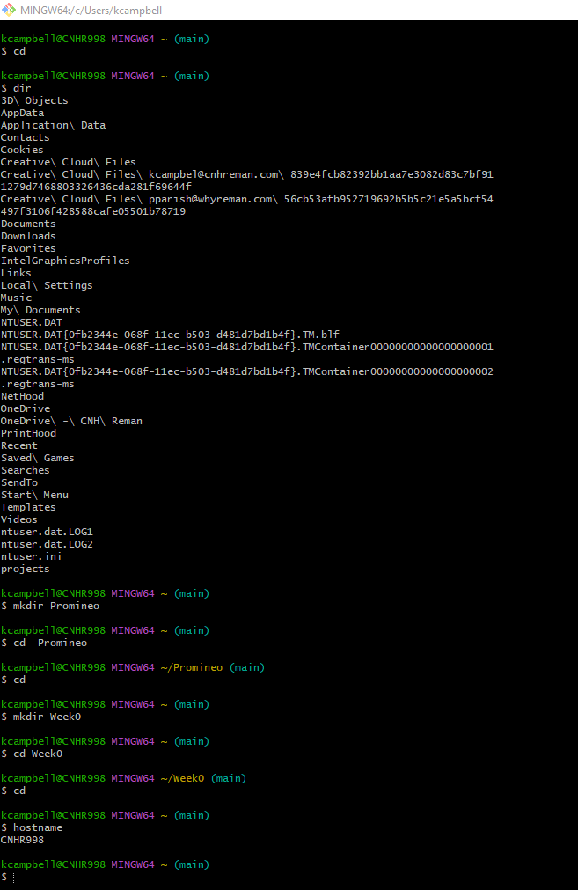

1. Go to <https://zoom.us/test> and join a test meeting. Follow all the prompts to join the meeting and test your audio and video. Once you have joined the test meeting, click on the green shield icon in the top left corner of the screen, choose Statisticson the left-hand column, and take a screenshot of that window and post it below.

Insert a screenshot of the Statistics window here:

